RSM 222 – Chapter 13 In- Class Exercise
Part I - NPV analysis
Mountain Adventures Company (MAC) is an independent shop operating out of Canoe Lake in the Algonquin Region. The store is made up of 2 parts: A retail section where visitors can purchase clothing and other supplies for their camping trip and a rental section where visitors can rent canoes, kayaks and paddle boards to go on the lake.
Recently, Raffi, the owner of MAC, is considering expanding the rental portion of the store to include tents and other camping essentials.
Raffi provides you with some initial numbers he obtained based on an analysis of this potential project:
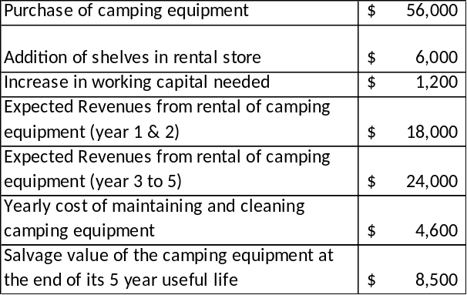
According to Raffi, the revenues from the camping rentals should increase in year 3 as word of mouth will pick up and increase the demand for the camping equipment.
The project would fit well with the current operations of MAC as the rental of the camping equipment could be handled by the existing staff from the rental store. The salary expense for the staff is $62,000 per year.
Raffi also believes that offering camping equipment could allow the shop to increase their revenues for the existing canoe and kayak rental equipment. He believes that visitors would favor his store over other stores in the region as he would be one of the only place to offer a “one-stop” rental options for campers. He did not include this information above as he could not come up with a reliable estimate.
The company’s desired rate of return for similar projects is 10%.

Question 1: Identify all the relevant cash inflows and outflows that should be considered in the capital budgeting decision for MAC’s expansion of camping equipment rental.

Question 2: Compute the NPV of the proposed project

Part 2 – Comparing different projects with NPV computations
Raffi indicates that he is also considering investing in some recreational equipment such as pic-nic tables, lounge chairs, climbing structures and water games to set up a recreational area for families. The purpose of this recreational area would be to provide entertainment to families who are making a day trip to the lake. The zone would be restricted and families would need to pay a flat $15 fee per day to have access to the recreational zone.
Raffi has provided you with the estimated costs and projected revenues for this project.
Recreational Equipment | $ 42,000
Increase in working capital needed | $ 2,000
Expected Revenues from admission fees (year 1) | $ 18,000
Expected Revenues from admission fees (year 2) | $ 20,000
Expected Revenues from admission fees (year 3-6) | $ 23,000
Yearly cost of maintaining recreational equipment | $ 3,500
Additional costs for staff and recreational supervisor | $ 8,000
Salvage value of recreational equipment | $ 10,000
Excel for your computations.
Comparison of NPV
Camping Equipment Rental
Recreational Equipment

What are some additional qualitative factors that should be considered in order to make a balanced recommendation to Raffi?

